Model Architecture Experiment

Model 1

Epoch 1/5

10000/10000 [==============================] - 260s - loss: 0.0129 - val_loss: 0.0015

Epoch 2/5

10000/10000 [==============================] - 257s - loss: 0.0014 - val_loss: 5.7650e-04

Epoch 3/5

10000/10000 [==============================] - 254s - loss: 9.4860e-04 - val_loss: 2.9327e-04

Epoch 4/5

10000/10000 [==============================] - 256s - loss: 6.4720e-04 - val_loss: 7.8066e-04

Epoch 5/5

10000/10000 [==============================] - 257s - loss: 8.3015e-04 - val_loss: 2.8912e-04

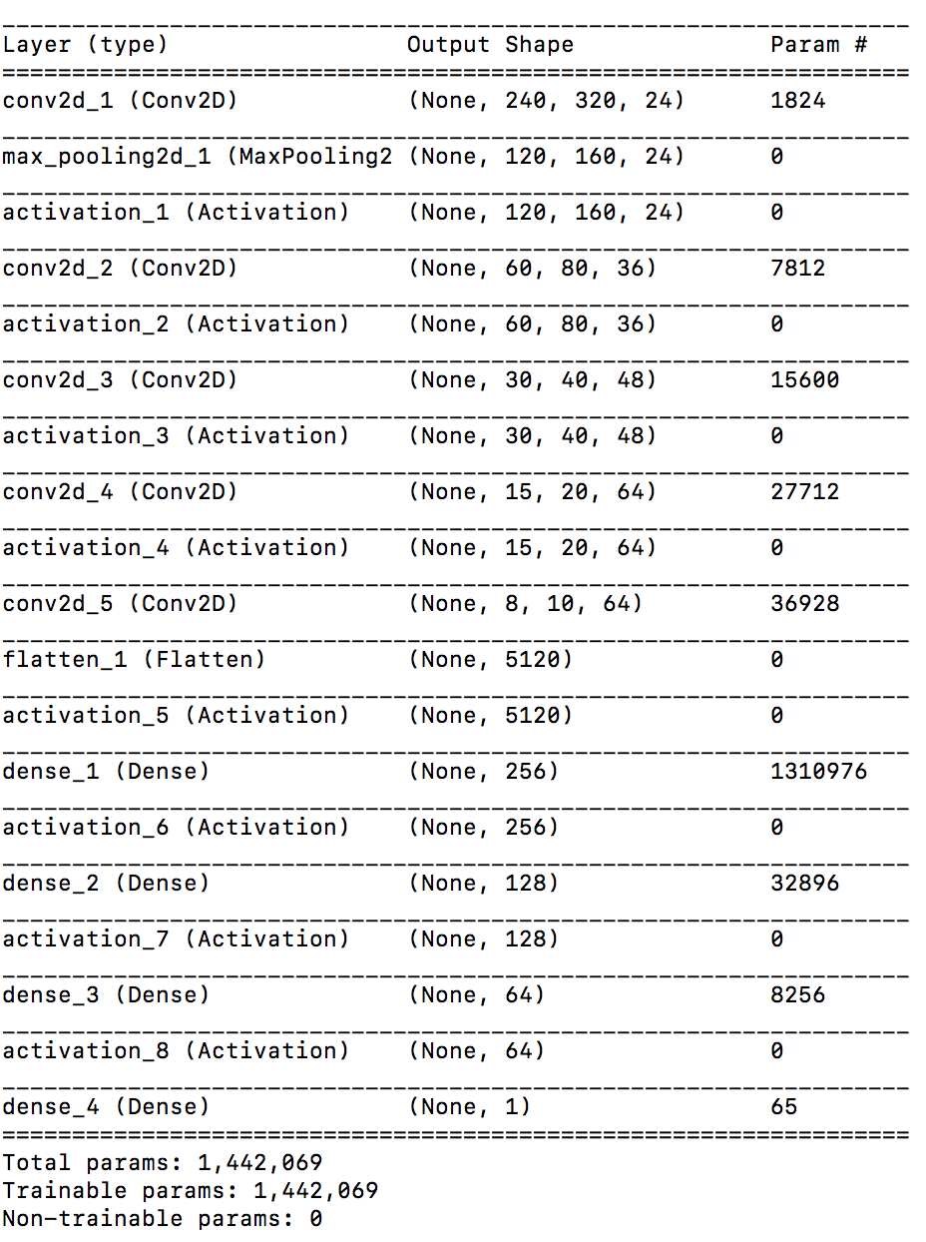

Model 2

Epoch 1/5

10000/10000 [==============================] - 195s - loss: 0.0542 - val_loss: 0.0039

Epoch 2/5

10000/10000 [==============================] - 173s - loss: 0.0023 - val_loss: 0.0010

Epoch 3/5

10000/10000 [==============================] - 172s - loss: 0.0011 - val_loss: 0.0023

Epoch 4/5

10000/10000 [==============================] - 171s - loss: 7.7616e-04 - val_loss: 3.3902e-04

Epoch 5/5

10000/10000 [==============================] - 169s - loss: 6.7593e-04 - val_loss: 3.8515e-04

